

***Tunisia Tour: Roman and Southern Tunisia***

***2024 – 2025***

***12 jours 11 nuits***

***(1968,1 km)***

A Phoenician trading post, a Carthaginian land, a Roman colony and then a region under Arab domination, Tunisia remains associated with the successive invasions of which it was the target.

From this troubled past there remains a cultural diversity that is illustrated in particular by the architectural splendours of its archaeological sites, but also in the heart of its cities where the arts and traditions dazzle.

***The Strong Moments :***

1. Here we offer you a captivating discovery tour! You will combine the exploration of southern Tunisia with the discovery of grandiose cities and sites in the footsteps of the civilizations that forged this country.

Discover much of southern Tunisia.

1. Discover the ***archaeological site of Carthage***, the ***Medina of Tunis***, and the village of ***Sidi Bousaid.***
2. Visit the main attraction of Tunisia's largest museum ***(Bardo)*** and its magnificent collection of Roman mosaics.
3. Explore the ***ruins of Dogga*** and learn about the Roman heritage in Tunisia.
4. Discover ***Kairouan*** , the fourth holiest city in Islam and the spiritual capital of Tunisia.
5. Explore the ***palm trees*** , the ***mountain oases*** of Tozeur.
6. Discover chbika, Tamarza, Midès.
7. Cross ***Chott Djérid*** , the largest salt lake in North Africa.
8. Discover ***Douz*** the gateway to the desert.
9. Discover Tataouine, its ***Ksours*** and the ***Berber villages***.
10. Visit the ***cave dwellings*** in Matmata.

Visit ***El Jem***, the ancient city of Thysdrus, one of the most prosperous in Roman Africa.

12 . Discover ***Cap Bon***: the main attractions of the north-eastern tip of Tunisia; you visit ***Hammamet***, ***Nabeul, Kerkouane, Kélibia***.

Embark today on an adventure that will remain forever etched in your memories. Let the magic of Tunisia take you away and guide you through unique landscapes, cultures and experiences.

Join us in creating unforgettable moments and exploring the best of what our beautiful nation has to offer. Your adventure awaits, ready to unfold every step of the way.

***The tour in detail:***

***Day 1: Arrival in Tunis:***

_Arrival to Tunis Carthage Airport.

_Reception and Transfer to your Hotel.

***Day 2: Tunis / Carthage / Sidi Bousaid / Tunis :( 38 km):***

_ Breakfast

_Visite of the ***archaeological site*** of Carthage: We start with the hill of Byrsa which dominates the bay of Tunis and then the tophet, the great sacred space of the Carthaginians, the Punic ports and the baths of Antoninus, the cisterns of Maalga and the theater of Carthage.

_Lunch

_Direction ***village of Sidi Bousaid***: a village renowned for its Moorish architecture, its colours and its poetic atmosphere that is a source of inspiration for painters and artists.

_Visit the Baron d'Erlanger Museum , a superb residence built at the foot of the village of Sidi Bousaid in a park overlooking the sea by Baron Rodolphe d'Erlanger.

_Take a coffee at the famous ***Café des Nattes***.

_Return at the hotel: dinner and accommodation.

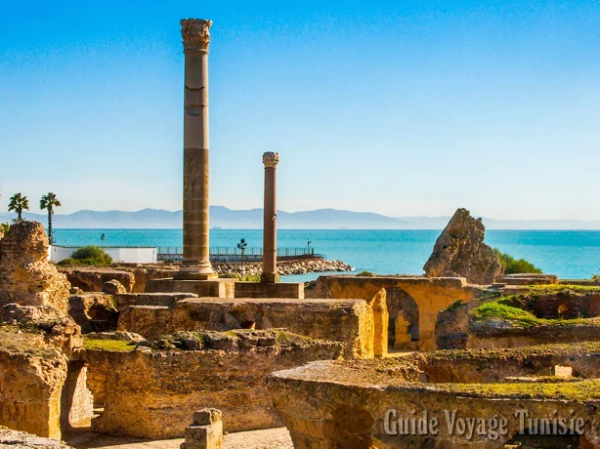 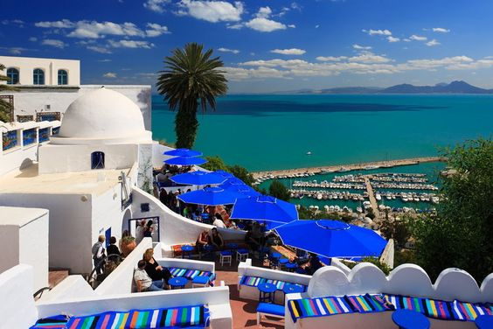

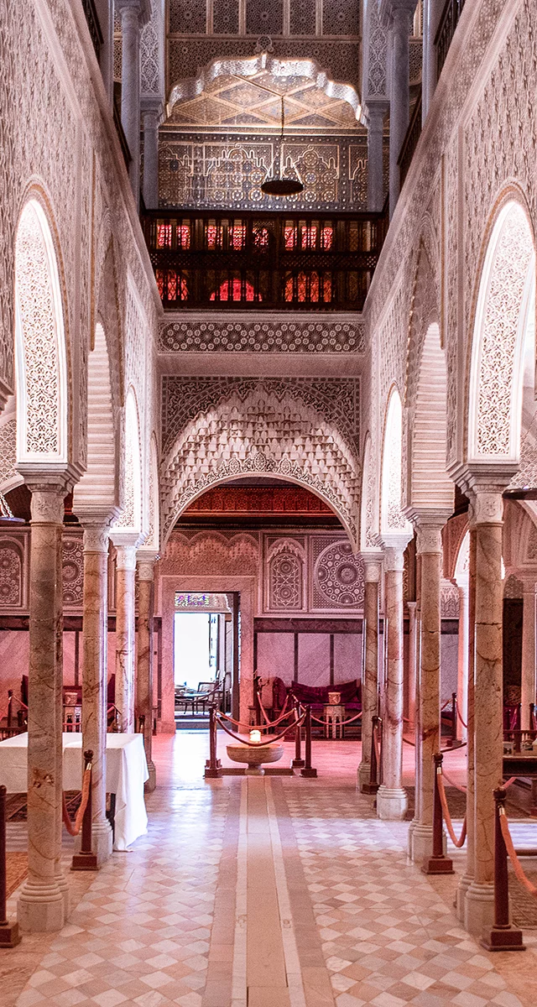

***Day 3: Tunis/Kairouan:(161.2 km)***

_Breakfast.

_ Direction Kairouan.

_Arrival in ***Kairouan***; Visit the city of Kairouan, one of the cities of Islam, called the city of three hundred mosques where you will discover: The ***Great*** Mosque, ***the Barber's Mosque***, the ***Aghlabid Basins***, ***Sidi Abid Ghariani***.

_ Visit to the Medina and tasting of the local cake "Makroudh".

_Lunch.

_ Visit to ***the Raqqada Museum*** of Islamic Art which is the largest museum dedicated to collections of Islamic artifacts in Tunisia.

Destination hotel: Dinner and Accommodation.

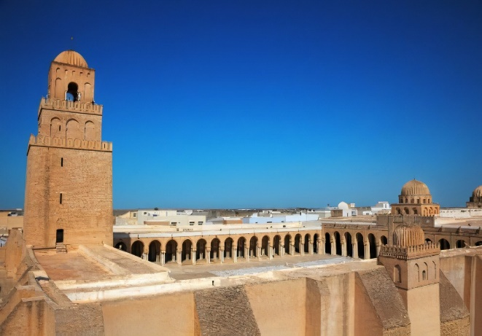 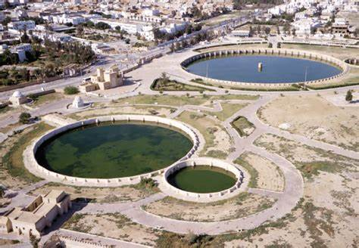

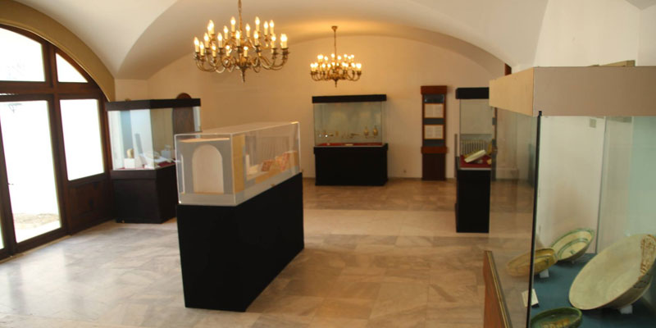

***Day 4 : Kairouan/Sbeitla/Tozeur: (325 km)***

_ Breakfast.

_ Drive to ***Sbeitla*** (Sufetula ): Discover the exceptional ***archaeological site*** of ancient Sufetula, one of the few Roman villas to have dedicated three temples to the Capitoline Triad.

_ Lunch in Gafsa.

_ Continue south.

_ Arrival in ***Tozeur***, located on the edge of the most important oasis in Tunisia, called the old Ouled el Hadef district with the possibility of a horse-drawn carriage ride in the palm trees.

_ Destination at the hotel: Dinner and accommodation.

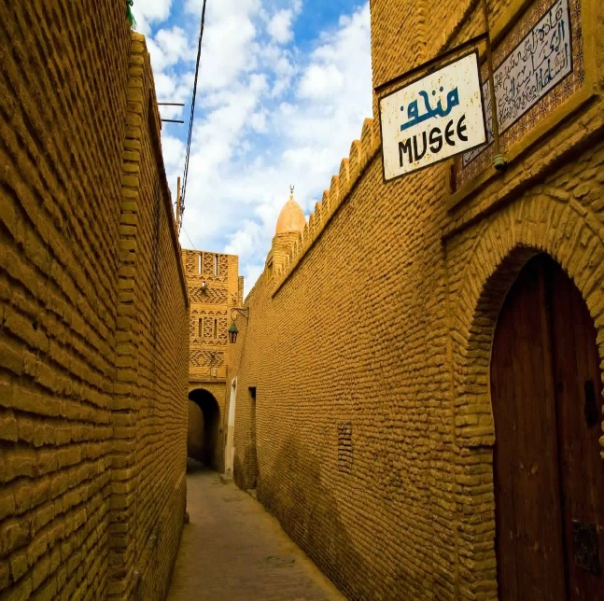 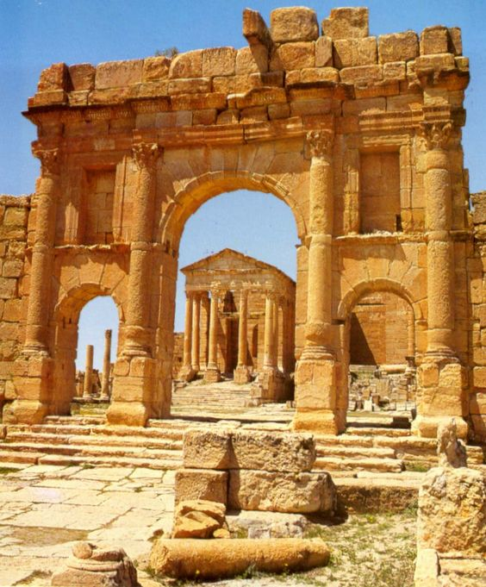

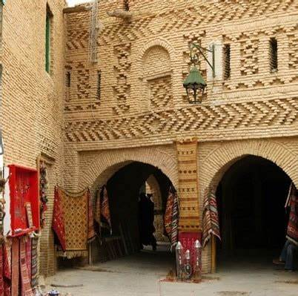

***Day 5 : Tozeur :***

_Breakfast

_ Starting the day with the resumption of the 4x4s to access the mountain oases that we will visit;  ***Midès***, *the* ***canyons of Tamarza***, the ***waterfalls of Chebeika*** (***in Extra***).

_Lunch.

_ Visit of the place called "***Corbeille de Nafta***", and its pedestrian walk.

_ Then take the road to ***Ong Djamel*** (filming location of the "Star Wars" saga, Star Wars) to see the sets of the film. You will be able to watch the sun set over the great dunes of the Sahara.

_Return at the hotel: Dinner and accommodation.

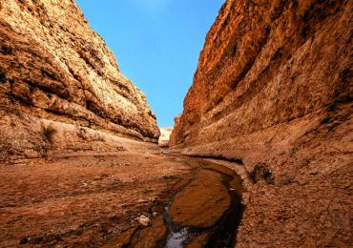 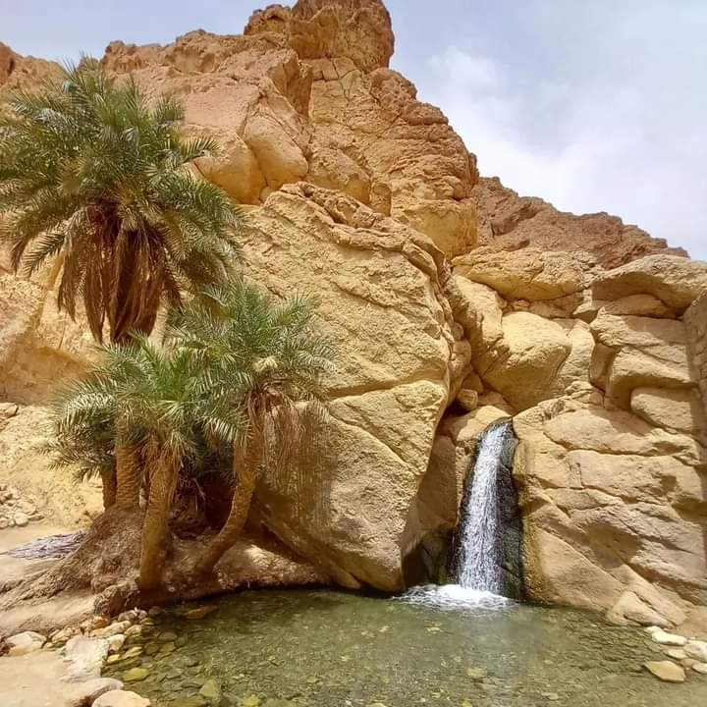

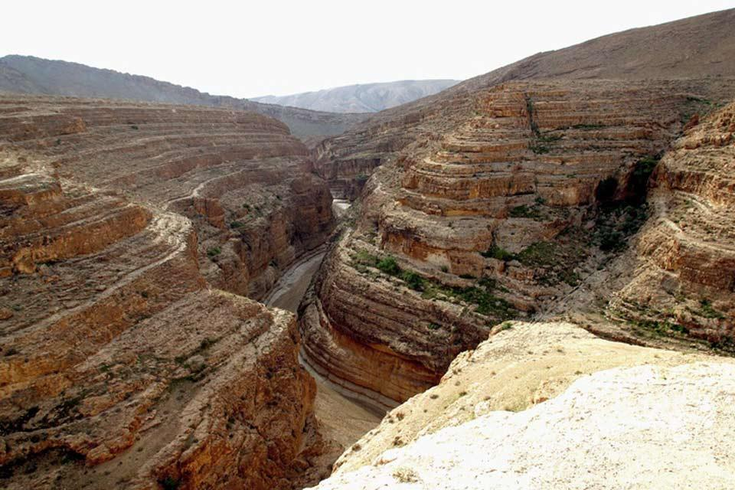 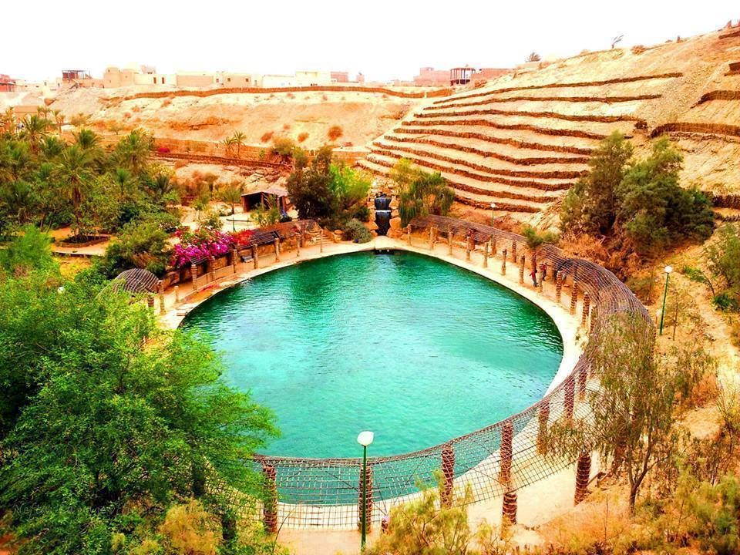

***Day 6 : Tozeur/ Douz/ Matmata/ Tataouine:(373,1)***

_Breakfast.

_Départ from ***Tozeur*** to Douz crossing the Salt Lake ***Chott el djérid***: Photo stop to capture the mirages and the white immensity of this "salt desert".

_Arrival in ***Douz***, a crossroads town in southern Tunisia nicknamed the gateway to the desert.

_Visit to the ***local*** market and especially its typical cattle market.

_Lunch.

_ Possibility to take a camel ride in the white sand dunes ***(Extra).***

_Départ from Douz to Matmata.

Happens in ***Matmata*** where you will explore the troglodyte dwellings.

_Direction to Tataouine.

_Arrival in ***Tataouine***.

_ Dinner and accommodation at the hotel.

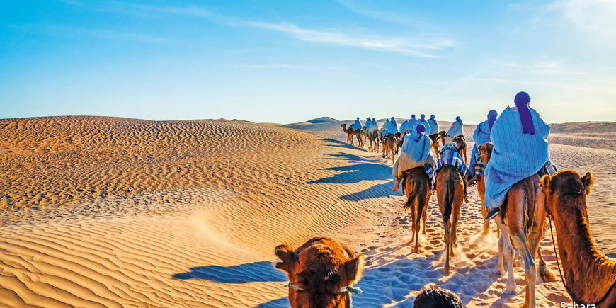 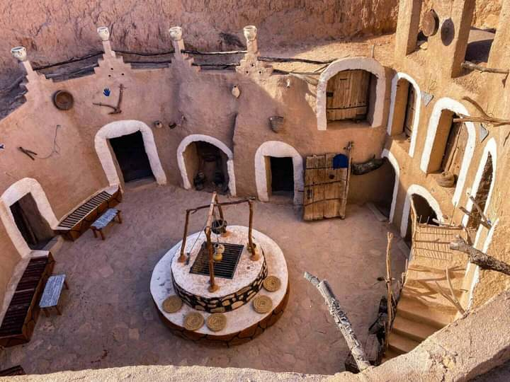 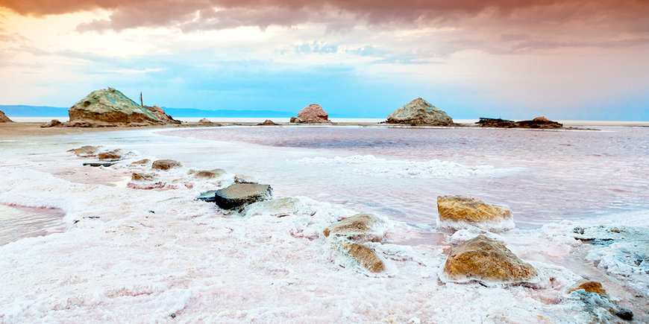 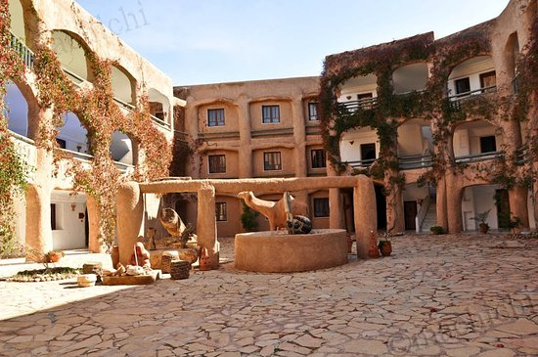

***Day 7: Tataouine/Gabes/Sfax :(329 km)***

_Breakfast.

_Visit of ***the city centre*** with tasting of local pastries.

_ Visit ***to the Museum*** of the Memory of the Earth, illustrating the rich presence of dinasaur in the region.

_Visit ***Mausoleum of the 7 Sleepers***: an old mosque in a troglodyte setting on the way to Chenini.

_Visit of ***Chenini***, a Berber village adjoining a flank of the Djebel.

_Visite of ***Ksar Hdada***, the filming location of the Star ***Wars*** movie**.**

_Lunch.

_Direction Gabes.

_We continue to go back in time in ***Gabes*** with a visit to the Jara market

which is a sought-after place of trade since it specializes in spices and henna.

_Départ to ***Sfax.***

_Arrival in Sfax: Dinner and accommodation.

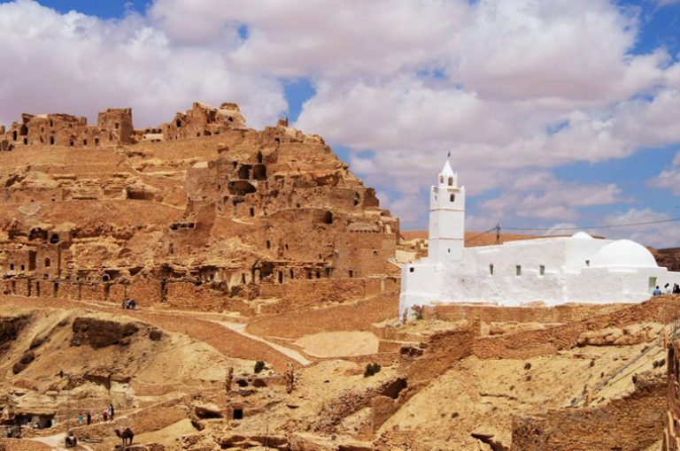 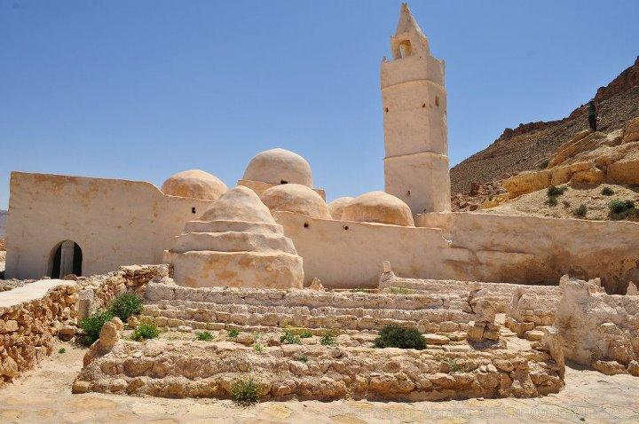

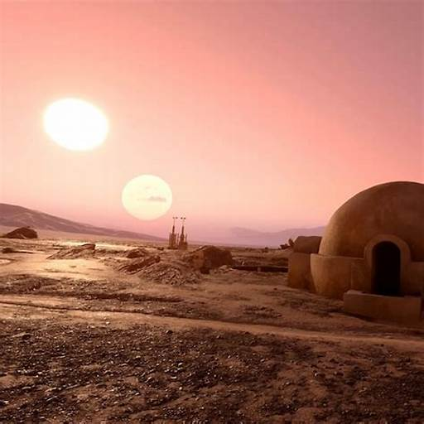 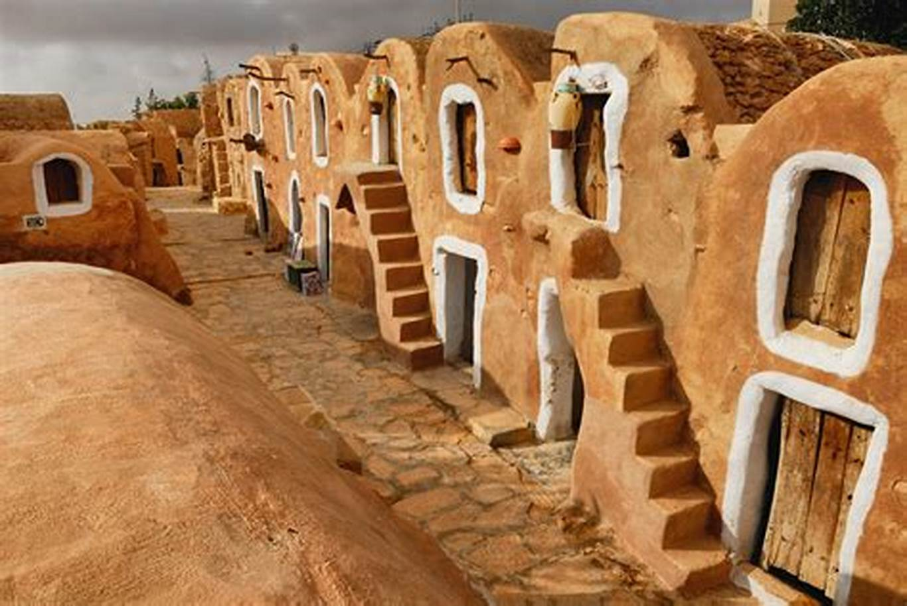

***Day 8: Sfax/El Jem/Monastir/Sousse/ Hammamet :(253.1 km)***

_Breakfast.

_ Departure to ***El Jem***.

_ Visit the ***amphitheatre of El Jem*** the ancient thysdrus: which is the largest Roman monument in Africa and the 3rd largest in the Roman Empire.

_ After visiting the amphitheatre, head to the ***archaeological museum*** which has many mosaics.

_ Nearby, a visit to Villa ***Africa***, which is a reconstruction of a house

_Lunch.

_ Continue to ***Monastir***.

_ Arrival in Monastir: Visit the ***mausoleum of Bourguiba*** and the ***ribat***, an imposing fortress.

_ Direction towards Sousse.

_ Arrival in Sousse: Visit the ***marina*** of Kantaoui, then the medina of Sousse, capital of the Sahel region.

_ Destination in Hammamet.

_ Arrival in Hammamet: Dinner and accommodation at the hotel.

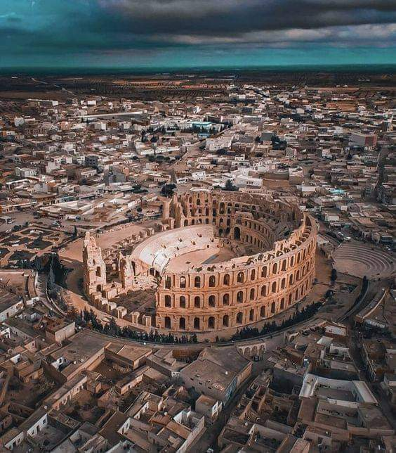 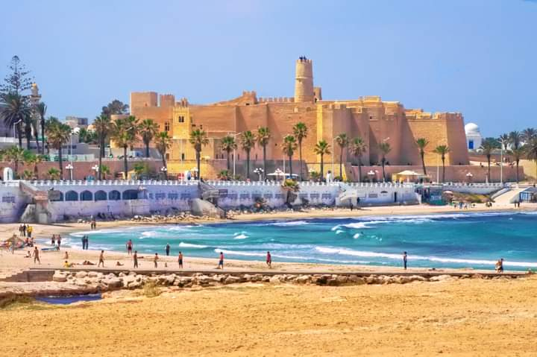

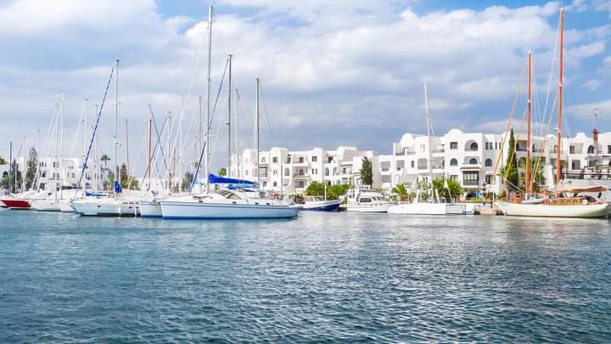 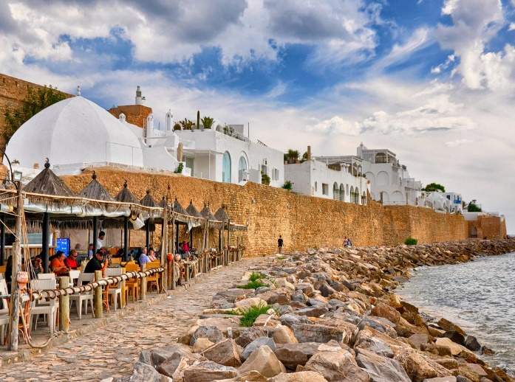

***Jour 9 : Hammamet/nabeul/Kélibya/Kerkouane/Haouaria/Hammamet***: ***(203,4 km) :***

_Breakfast.

_Discovery of ***Hammamet***: its small medina surrounded by high ramparts by the sea, its Kasbah (beautiful view from its summit).

_Départ to ***Nabeul***, the ancient Roman Neapolis, considered the city of pottery and ceramics.

_Direction ***Kélibia***, the town known for its fishing port.

_Visit you grand ***Fort Byzantium.***

_Passant later by the ancient Punic city ***of Kerkouane***, which is home to a Punic city and necropolis inscribed on the list of the world's heritage of Unisco.

_Départ to el ***Haouaria***, the city of ways, where you will have lunch and visit the artificial caves that were dug by prisoners or slaves under the authority of the Carthaginians and then the Romans.

_Return in Hammamet: Dinner and Hotel Accommodation.

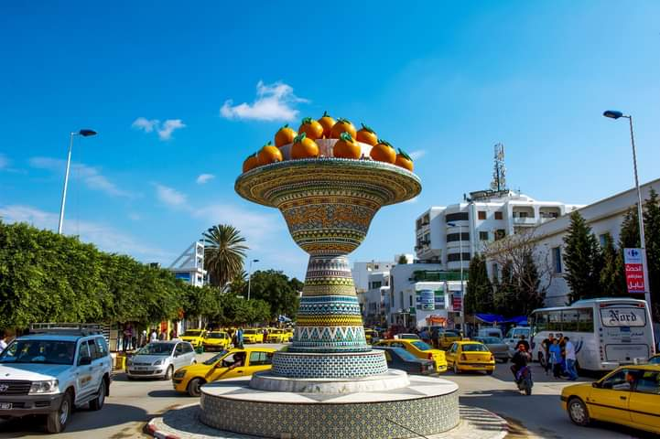 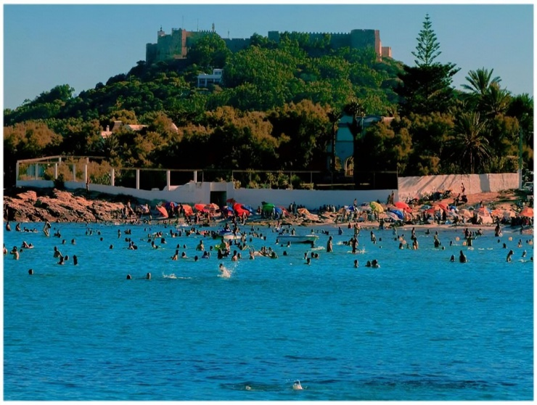

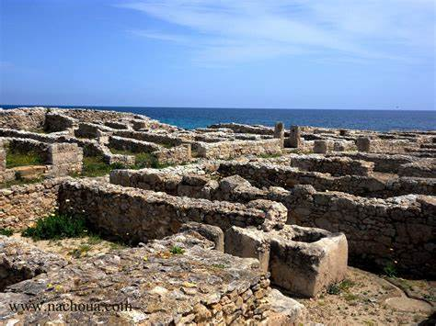 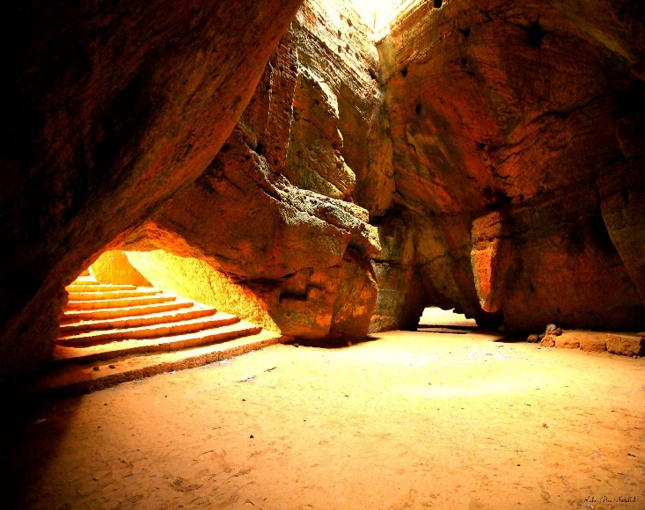

***Jour 10 : Hammamet/Tunis  (65,8 km) :***

_Breakfast.

_Départ to *Tunis*.

_Visit of the ***Bardo National Museum***: the second most important museum on the African continent.

_Lunch.

_Départ to the historic ***city of Tunis*** on a guided tour: where you explore the shops, mosques, and monuments of the historic medina.

_Visit the ***wine cellar*** for demonstration and tasting.

_Direction hotel: Dinner and accommodation.

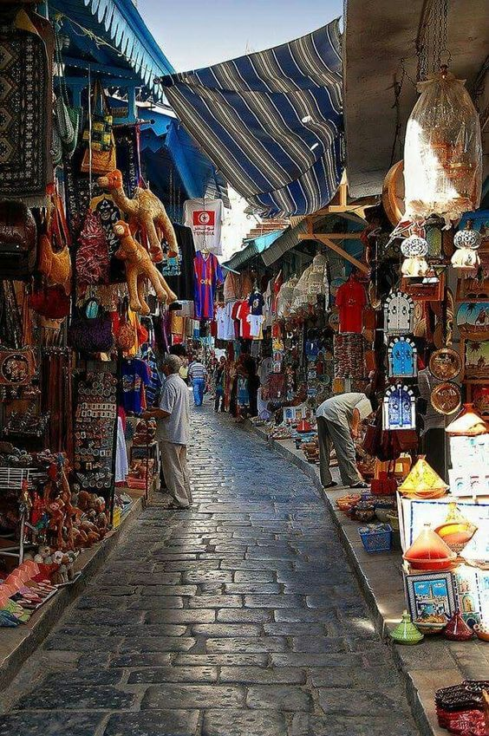 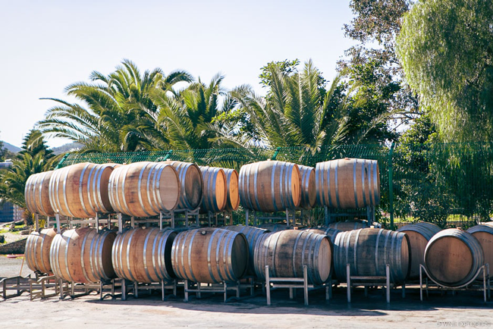

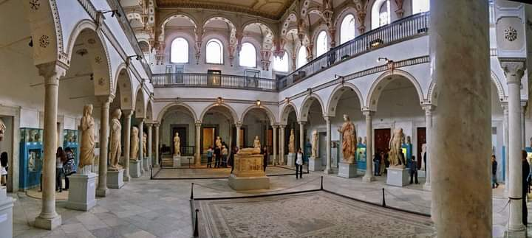

***Jour 11 : Tunis/Dougga/Testour/Tunis ( 219,5 km):***

_Breakfast.

_Départ from Tunis to ***Dougga***.

_Arrival in Dougga.

_Visite of the ***Dougga archaeological*** site: which is a major site of Antiquity in Africa because of its size, its state of conservation, its monuments: This site is classified as a World Heritage Site of the Unisco: let's discover this site (the theatre, the capitol, the forum, the temple of Coelestis, the house of the trifolum, the alleys).

_ Lunch at ***Dar Jdoud***: a culinary, cultural and tourist area with panoramic views of the monuments of the Dougga site.

_ Visit to the village of ***Tetour***: The Andalusian soul that is an icon of the Andalusian passage in the North African region.

_Return in Tunis.

_Dinner and hotel accommodation.

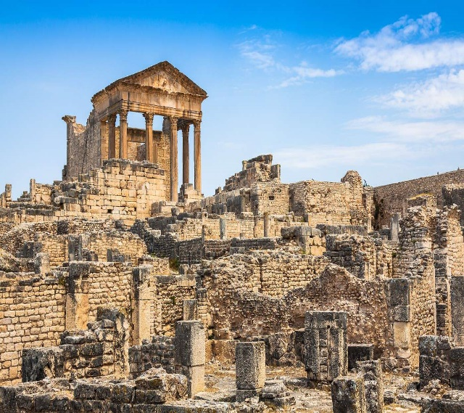 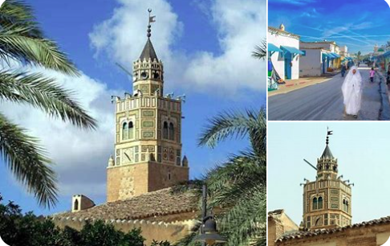

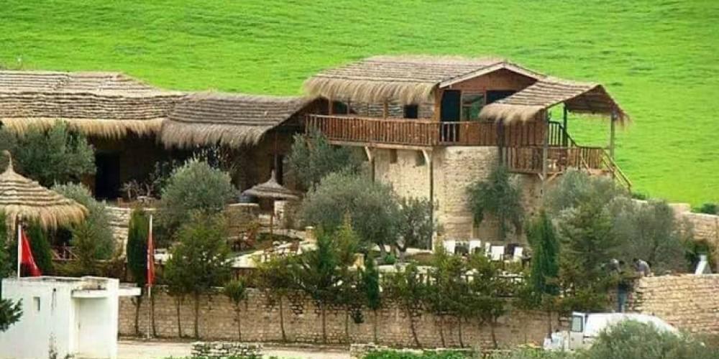

***Day 12 : Tunis / Departure :***

_Departure from your hotel and transfer to the airport.

***Includes:***

_Half-board accommodation 5*/4*.

_Guide English or Francophone.

_De water 1 bottle daily per person per day on the bus during the trip.

_Transport Tourist-Comfort class with air-conditioned bus.

_Taxe of stay.

_ All entrance fees to museums, tourist sites.

***Excluded:***

_Lunch .

_Jaunt camel ride ***20 USD.***

_Calèche ***20 USD.***

_Tower and Jeep 4x4 ***50 USD.***

_Tower and Quad ***30 USD.***

_Artisant, carpets and souvenirs: you can haggle with the craftsmen below under the guidance of the local guide.

***List of hotels:***

_Hotel Africa Tunis 5*

https://www.bing.com/travel/hotels

_ Hotel Kasbah Kairouan 5*

lakasbah.com-tunisia.com

_Hotel Mouradi Tozeur 4*

www.elmouradi.com

_Hotel Sangho Tataouine 3*

<https://www.facebook.com/SanghoPrivilegeTataouine>

_Hotel syphax sfax 4*

https://www.facebook.com/hotelsyphax

_Hotels Maheri Hammamet 5*

[**mehari_hammamet/hammamet**](https://www.bing.com/aclick?ld=e8d09OvJJ70dFPW1ds63etbTVUCUzBwlOerUKqp7BGRuA6NhGNRsn9c51aCnz_mnmUbeKD3ctmW3cr9qG6hEv7qVycqzhcKqUkRdW026b9zX7UnwCudVMqCLFe3OU4tHZdncpOqNaXLy2mnphBteZp8pIPFutrSPlDzr8870aGAh_sXdagPbIPQw005YT-2J7Sl2H5VQ&u=&rlid=f0b009b2145e102170f36cc3d29662b6&ntb=1&ntb=1)

***Circuit Summary:***

**_Jour 1: Arrival**

**_Jour 2 : Tunis/Carthage/Sidi Bousaid/Tunis**

**_Jour 3 : Tunis/Kairouan**

**_Jour 4 :Kairouan/Sbeitla/Tozeur**

**_Jour 5 : Tozeur**

**_Jour 6: Tozeur/Douz/Matmata/Tataouine**

**_Jour 7: Tataouine/Gabès/Sfax**

**_Jour 8 :Sfax/El Jem/Monastir/Sousse/Hammamet**

**_Jour 9: Hammamet/Nabeul/Kélibia/Kerkouane/Haouaria/hammamet**

**_Jour 10 :Hammamet/Tunis/Bou Argoub/Tunis**

**_Jour 11 :Tunis/Dougga/Testour/Tunis.**